

FTD le 09/01/2011

Photos du 11/04/2010

**30 Rue Cabanis**

**Villa de Lourcine**



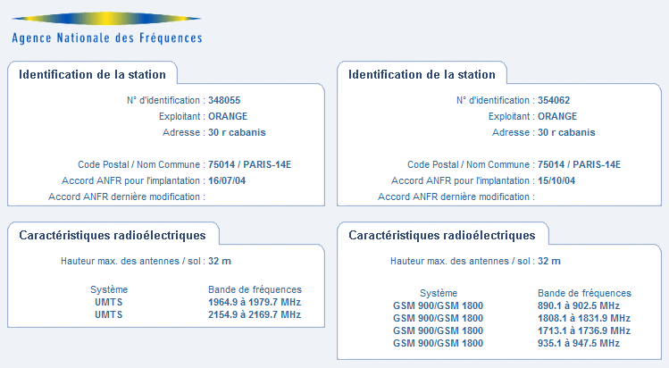

**Secteur vers Rue Dareau**

|  |  |  |  |  |
| --- | --- | --- | --- | --- |
| **BCCH** | **LAC** | **CID** | **TRX** | **Divers** |
| **30** | 768 | 34377 | 3  H44, H46, H30 | - |
| **555** | 27769 | 3  H572, H614, H555 |

**Secteur 2**

|  |  |  |  |  |
| --- | --- | --- | --- | --- |
| **BCCH** | **LAC** | **CID** | **TRX** | **Divers** |
| **5** | 768 | 56725 | 3  12 / 22 / 5 | - |
| **551** | 59582 | 4  559 / 590 / 594 / 551 |

**Secteur 3**

|  |  |  |  |  |
| --- | --- | --- | --- | --- |
| **BCCH** | **LAC** | **CID** | **TRX** | **Divers** |
| **54** | 768 | 41114 | 1  54 | - |
| **528** | 54774 | 4  588 / 606 / 612 / 528 |

|  |  |
| --- | --- |
| RAM |GSM | -111 dBm |

|  |  |
| --- | --- |
| RAR | 4 |

|  |  |
| --- | --- |
| RAM |DCS | -94 dBm |
|  | CRO 32 |

|  |  |  |
| --- | --- | --- |
| T3212 | 30 | 180 (TEMS) |

|  |  |
| --- | --- |
| PRP | 7 |
| DSF | 13 |

|  |  |
| --- | --- |
| GSM | EAH B MB1 |

|  |  |
| --- | --- |
| DCS | EAHC B MB3 |

|  |  |
| --- | --- |
| RLT | 20 |

|  |  |
| --- | --- |
| DTX | Use |

|  |  |
| --- | --- |
| MT |GSM  MS-TXPWR-MAX-CCH | 5 |33 dBm |

|  |  |
| --- | --- |
| BA  BS-AG-BLKS-RES | 2 |

|  |  |
| --- | --- |
| CM  CCCH configuration | 0 |Not Combined |

